APRIL 2024
Subject: Check in on your TG Financial Benefits!

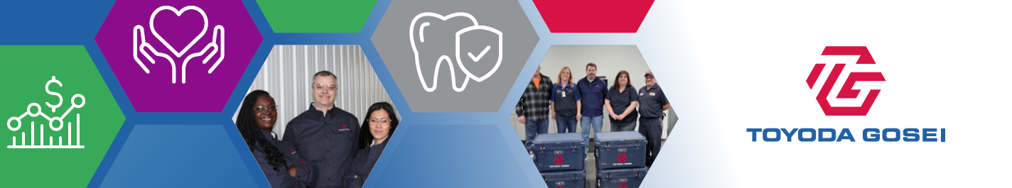

TIME TO CHECK-IN ON YOUR TOYODA GOSEI FINANCIAL BENEFITS!
April is Financial Literacy Month - the perfect opportunity for you to brush up on your benefit plan-related finances! Take time to learn about the TG plans and programs that help you save and provide tax advantages for you!
Check in on TG Savings and Spending Accounts!  Your TG health care plans cover most of the cost of covered services. But for some expenses, you pay part of the cost. That’s where your health savings and spending accounts come in!  - Health Savings Account (HSA): If you’re enrolled in the Optimal medical plan, an HSA is available to help you save and pay tax-free for eligible medical, dental and vision expenses. You can stop, start or change your contributions anytime – and TG contributes, too! There’s no “use it or lose it” rule with an HSA, so your balance is always yours, to save and spend as you want.  - Health Care and Dependent Care Flexible Spending Accounts (FSAs): These tax-advantaged accounts let you save pre-tax funds from your paycheck to help pay tax-free for qualified health care or dependent care expenses, such as copays, coinsurance and day care expenses. These accounts have a “use it or lose it rule” so you’ll need to use the money you contribute by the end of the year.  - NEW for 2024! Lifestyle Spending Account (LSA): The LSA is a flexible and inclusive wellness program that is designed to support your health by providing money you can spend toward personal, everyday wellness needs. The LSA is funded by TG and is available to all team members, regardless of whether you’re enrolled in our medical plans. |   Check in today with your TG accounts!
Check in on your TG Retirement Savings!  It’s never too early (or too late) to start planning for retirement. Our TG 401(k) plan can be an important part of your retirement savings!  - You can save for retirement with before-tax dollars.  - The Company helps your 401(k) account balance grow faster with a dollar-for-dollar match on the first 3% of your pay that you save.  - You can change how much you’re saving anytime, and you can change the investment options you choose through ADP.  Now’s a great time to check in on your 401(k) benefits to make sure they help you reach your retirement goals.  Not enrolled yet? No better time than now! Start here and click the Create Account link. |   Check in today with your TG 401(k) benefits!
Check in on your TG Beneficiaries!  Beneficiaries are important. They’re the people who would receive a TG benefit – life and AD&D insurance, 401(k) balance, HSA balance – if you died. So, it’s a good idea to keep that information up to date. It’s easy to review your beneficiaries on file and make any changes you’d like.  - For Life and AD&D Insurance, check in here.  - For your HSA, check in here.  - For your 401(k) account, check in here. | 
Want to Check In on Your Other TG Benefits?
Be sure to visit our benefits website, tggroupbenefits.com
(password: TGNA; location: United States).
There, you’ll find helpful information about all your benefits.

